Knowledge Based Consulting Group

KBCG is based in the San Francisco Bay Area, with affiliates and expertise in both Europe and Asia Pacific. We were formed to serve client needs through the services of Senior Executives with extensive experience and vision.

KBCG provides experts that have the best available minds to give their advice on projects rather than technicians calculations. KBCG expertise is focused in real estate and entertainment industry market analysis, product development, database marketing, financial planning, and the applications of new technology.

Projects include themed attractions, hotels, resort and residential housing, cultural and performing arts facilities, entertainment retail, casinos, cruise ships, special events, and destination marketing programs.

The following pages provide descriptions of selected projects and representative clients:

- Real Estate Development
- Hotels and Resorts
- Attractions and Entertainment Retail
- Recreation and Tourism

Contact Information:

Clive B. Jones, Principal

Knowledge Based Consulting Group
19 Holly Ave.
Larkspur, CA 94939
Tel/ Fax (415) 924 – 6577
Mobile: (415) 726-9787
Also available via Skype

Real Estate

KBCG’s real state projects include mixed use projects, residential subdivisions, senior housing/ Silvertown projects, high rise condominiums, University related development, and office/ commercial buildings. Several of these projects (such as Fountain Grove Ranch in Santa Rosa and Summerlin in Las Vegas) have led to fundamental changes in the economic life and real estate values of their area

Representative Projects
- Fountain Grove Ranch
- Rancho Murrieta
- Caughlin Ranch, Reno
- Hokua Condominiums, Oahu
- Victoria Ward Apartments, Oahu
- Sun City West, Arizona
- Summerlin, Las Vegas
- University Village, Hawaii
- El Rancho Verde
- Trump Tower, Oahu
- Rancho California
- River Islands, Lathrop
- Marriott Office Park
- Waiawa, Oahu
- Villa Marin, San Rafael
- Yerba Buena Center, San Francisco

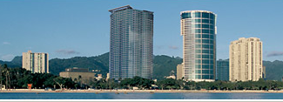
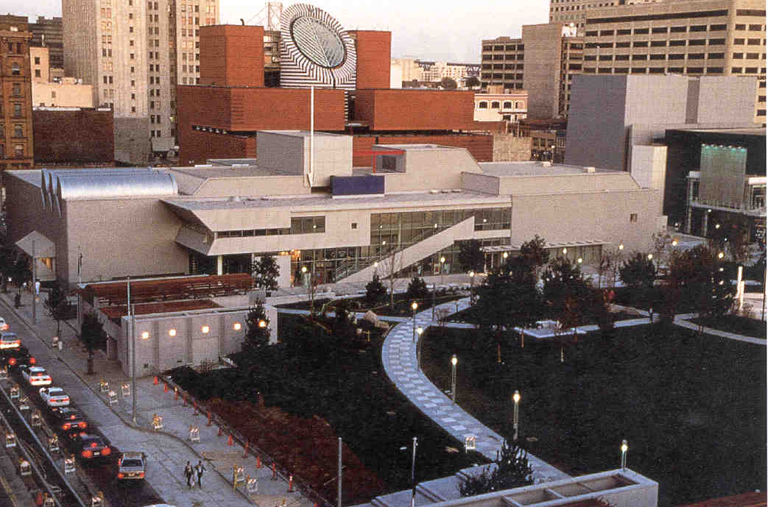

Hotels and Resorts

KBCG has been a consultant to hotels, resorts, and destination casinos throughout Asia-Pacific, the Americas, and Europe. The Hualalai resort received the Urban Land Institute Award of Excellence for master planned resort development, the Zagat rating as the finest resort in the US, and the Conde Nast award as the finest resort in the Pacific Rim for 2005

Representative Projects
- Hualalai, Hawaii
- Kapalua, Maui
- Marriott Vacation Clubs, Asia Pacific
- Outrigger Boutique Hotel, Honolulu
- Kaanapali, Maui
- Snowmass at Aspen
- Mauna Lani, Hawaii
- Northstar at Tahoe
- Royal Lahaina, Maui
- Harrah's Marina, Atlantic City
- Sheraton Walker Hill, Korea
- Molokai Ranch
- Tahoe Donner
- Venetian, Macau

- Chateau Montebello, Quebec
- Harvey’s, Lake Tahoe
- Keauhou, Hawaii
- SS Lurline, San Francisco
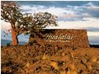

Attractions and Entertainment Retail

The role of entertainment retail has also been an important element of many of KBCG’s assignments. These projects include some of the most visited attractions and retail centers in the world. KBCG has also analyzed the market and prepared business plans for cruise development in Singapore, San Diego, and Santo Domingo

Representative Projects
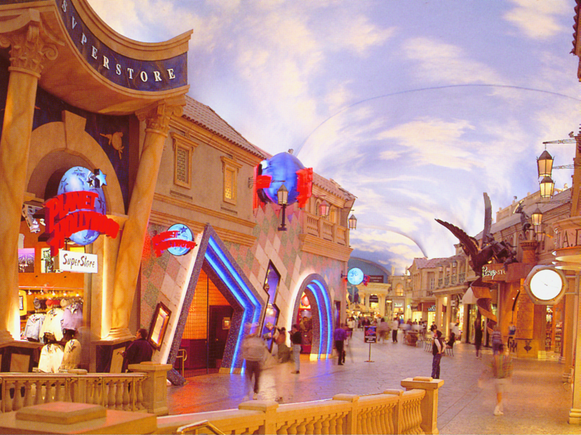
- PIER 39, San Francisco
- Clark Quay, Singapore
- Beringer Wine Estates, Napa Valley
- Urban Slalom, Tokyo
- Great America, Santa Clara
- Showcase Europe, Brussels
- San Francisco Bay Center
- Water Wonderland, Netherlands
- Space Needle, Seattle
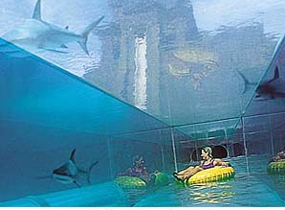
- Fisherman’s Wharf, Macau
- Gold Rush City
- Old Mint Museum, San Francisco
- Guam Aquarium
- National Aquarium of Taiwan
- Singapore Entertainment Center
- Old Sacramento
- Mozart Haus, Vienna
- Royal Hawaiian Shopping Center, Honolulu
- Cannery, San Francisco
- Sans Souci, Santo Domingo

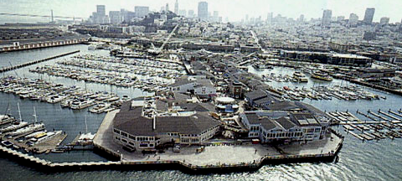

Recreation and Tourism

Complementing its private sector experience, KBCG assists tourism agencies develop master plans, investment strategies, marketing programs, and spotlight events. KBCG’s work for Tourism New South Wales is held up as a model for an effective and all-inclusive tourism master plan. Mr. Clive Jones of KBCG served on the Management Committee and Board of the Pacific Asia Travel Association and chaired their research and technology committees. Mr. Jones also serves the Board of the World Tourism Organization Business Council and is a member of their Advisory Council, Program Committee, and Leadership Forum.

Representative Clients
- Tourism New South Wales
- United States Travel and Tourism Agency
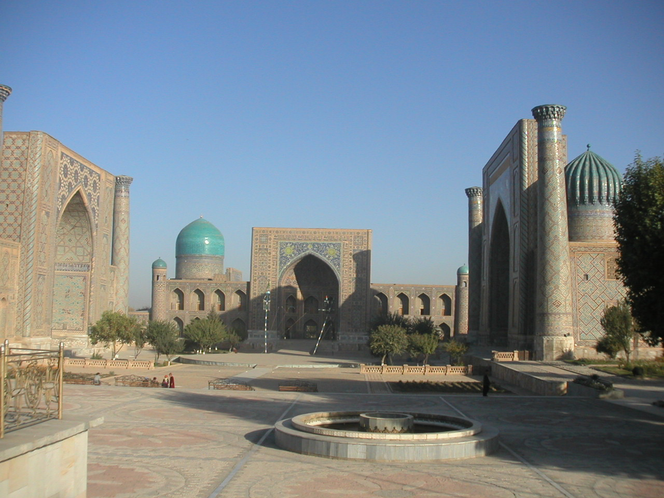
- Hong Kong Tourism Board
- Commonwealth of Puerto Rico
- Canadian Tourism Commission
- State of California
- Port of San Diego
- City of Oakland
- Singapore Tourism Board
- Interamerican Development Bank
- City of Scottsdale, Arizona
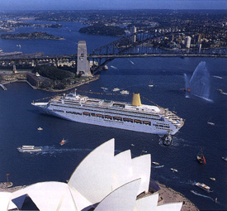
- U.S. Forest Service
- San Francisco Convention and Visitors Bureau
- Pacific Asia Travel Association
- World Tourism Organization
- National Park Service
  - Master Plan for South Rim Village Grand Canyon
  - Economic analysis for GGNRA
  - Concessioner Pricing Study
  - Analysis of Public Willingness to Pay for Outdoor Recreation



